**Introduction:** This assignment is all about “Story Exploration”. The program is created by me. The program provides children appreciate to read location and characters related story. Fun2Learn company manage this program. I have designed this application easy and user friendly for child. For doing this system I will use C# programming language as object-oriented program. The application will contain a log-in form and main form. The main form user can select module and see story. After reading story click on related option and see another story. User can save his last module story.

**Task-1**

This application creates by me using C# programming language. The name of this application is “Story Exploration”. This system contains so many functions, array, database, classes, objects and selection. The main functions of this application is “Data-Base”. Here I use four different database table for store information. I am try my best to full fil most of the requirements to complete this system user-friendly.

**User interface design with screenshots of my application named “Story Exploration” are given below:**

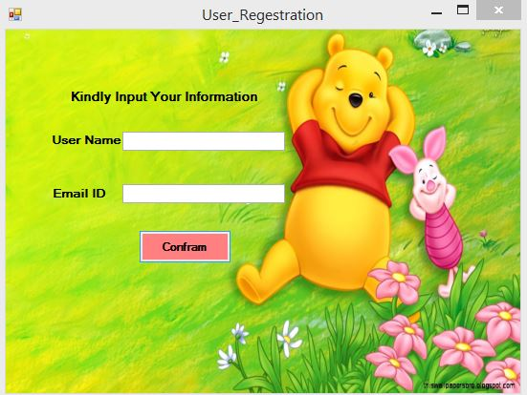

Log-In Form screen of the application.

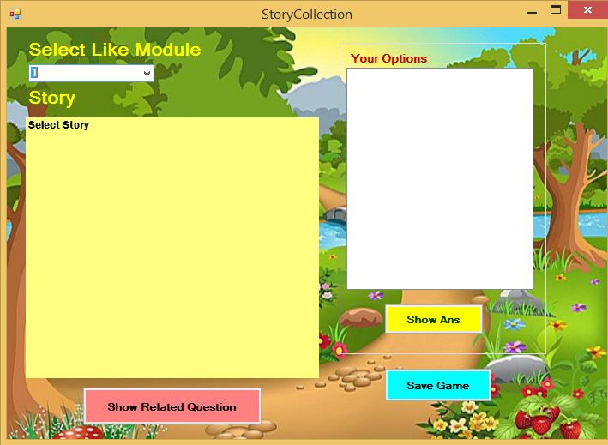

Main Form screen of the application.

**Task-2**

For knowing all the requirements of this application, it is essential to test the application step by step properly. So, I have test my systems all the functionalities for ensuring that it works properly or not. If I noticed any fault on the application then I have to solved them. I will sure that all my coding and graphical interface presentation works easily.

**Black-box testing Plan:**

In my black box testing I tested some visual functions for checking how my graphical interface actions. My all black box testing plan is given below:

**Log-In form:** When user start the program that time at first this form is showing. This form shows all the character of this form like labels, text-boxes and button.

**Function of Log-In Form:** Here need user to input his user name and his email and then click on the button.

**Main Form:** After complete log-in form step then main form is coming. Here shows many information for reading story for user. User can select module and see module story. After read the story click on button to see its related options and then select the option and see a new story.

**Function for main form:** Here user need to select like story from combo box and show story in label. After read a story click on button a see related question in text-box. Again, select the text-box and press the other button and see a new story in label.

**Black Box testing are given below:**

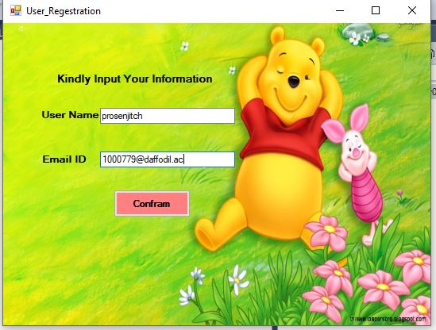

When open the Log-In form I input here user name and email id and input it successfully.



When submit user name and email then click on the coframe button and form changes.

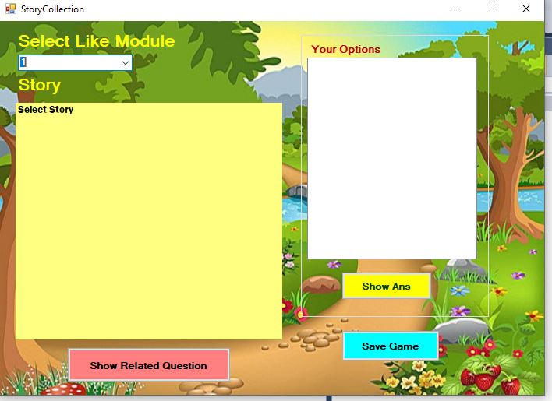

After click coframe button in log-in form the main form is shown.

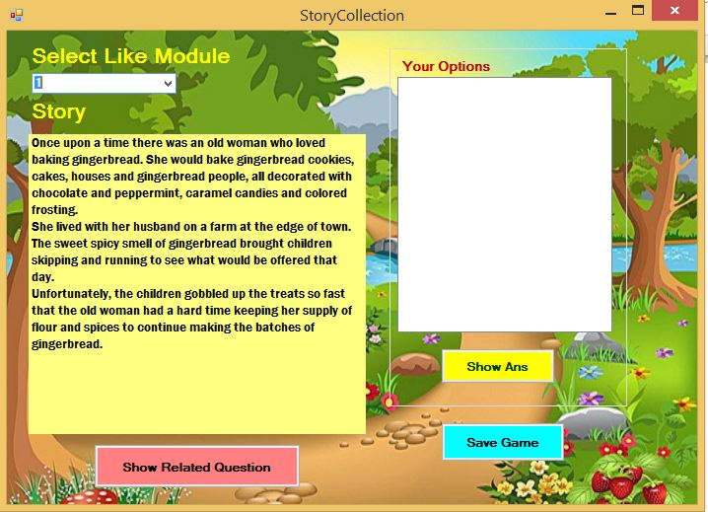

When select the like module story from the combo-box it shows the selected story on the screen.

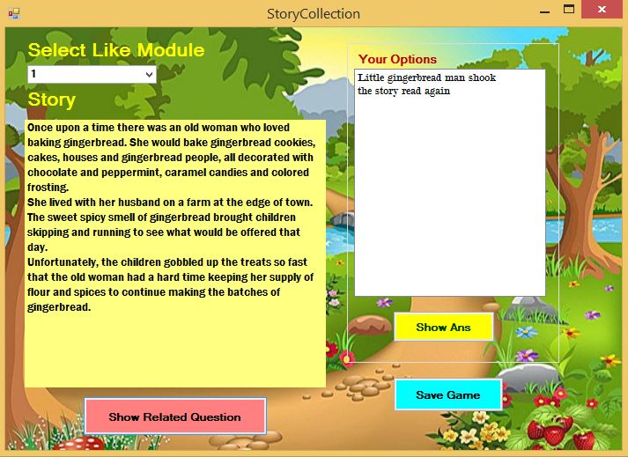

When click on “Show Related Options” button is shows the related options of the story on the screen.

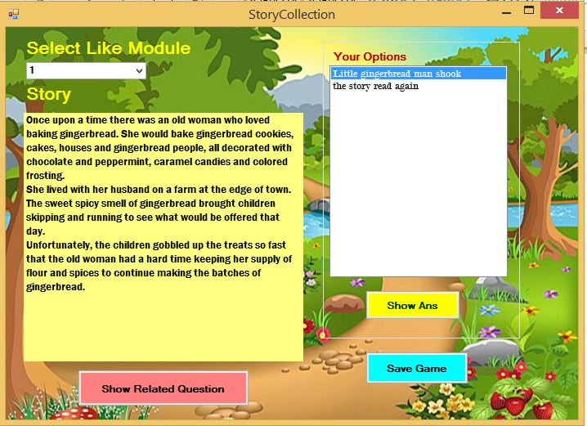

When show “Related Option”. I click on my choice able option.

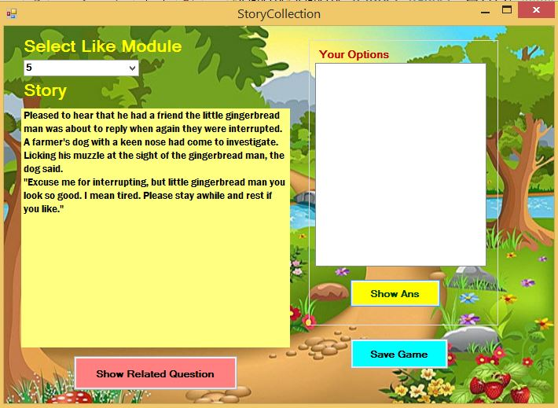

After selecting Related Option and then Click on “Show Ans” Button and then the story has changed.

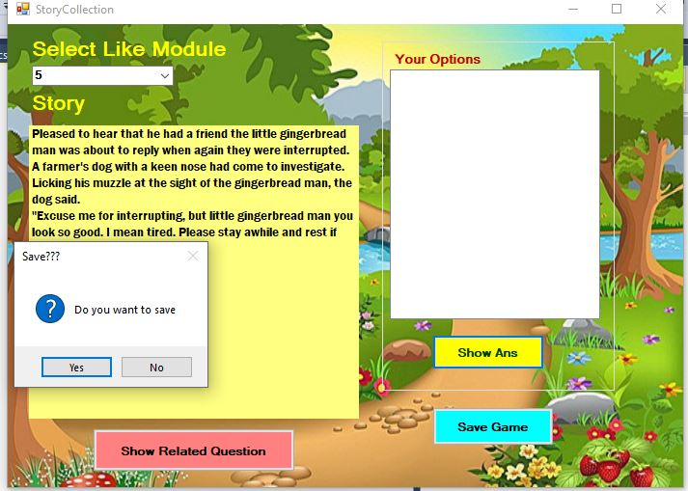

After reading story when I want to left the program that time Show a message in message box “Do you want to save”.

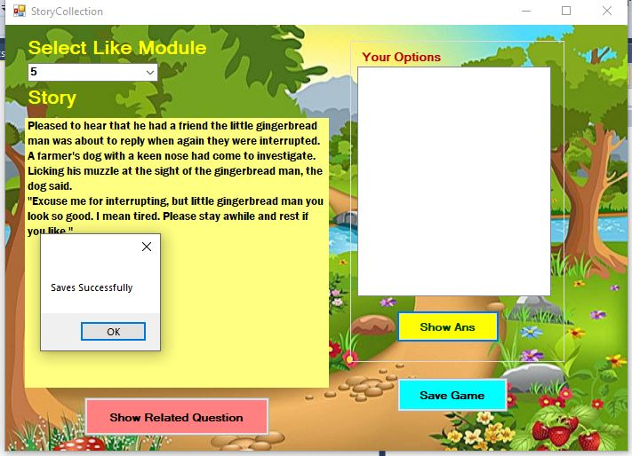

If you Click “Yes” button then save your last step story Successfully and show a message “Save Successfully”.

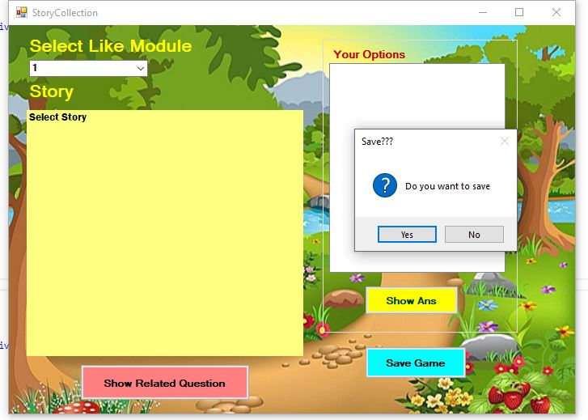

If you Click No, the program not saved your last step story and close the program.

**White Box testing plan:**

Now I am go to check some actions of the system because most of the actions depend each other and work likely similar. I will check function like coframe, select, show and update.

**Getting Input**: I will check the function for getting input properly or not.

**Next page calling**: I will check the function for after submit information then click on button the next form coming properly or not.

**Select Module:** I will check all the module show and select any module.

**Show Story:** I will check select module story show properly or not.

**Show option:** Check the function for show all the option are show.

**Select Option:** Check the function for show all the option and choice option select or not.

**Save last Step:** I will check select module story save properly or not.

**White box testing chart is given bellow:**

|  |  |  |  |  |  |
| --- | --- | --- | --- | --- | --- |
| **Test**  **No.** | **Test**  **Name** | **Screenshot of the Code** | **Expected Output** | **Actual output** | **Com** |
| **1** | Click  Action |  | Getting  Input  smoothly | A-Ex  Pected | N/A |
| 2 | Click  Action 2 |  | Next page  Calling  Without  Any bug. | A-Ex  Pected | N/A |
| 3 | Select  Modul  e |  | Selected  Any  Choice  Able  Module | A-Ex  Pected | N/A |
| 4 | Show  Story |  | Show  The  Selected  Story | A-Ex  Pected | N/A |
| 5 | Show  Opti  on |  | Show  All the  Related  Options | A-Ex  Pected | N/A |
| 6 | Select  Option  s |  | Select  The chose  Option  And  The story | A-Ex  Pected | N/A |

|  |  |  |  |  |  |
| --- | --- | --- | --- | --- | --- |
| 7 | Save  Last  Info |  | Save the last  Story  Till last  Step | A-Ex  Pected | N/A |

**Task-3**

**The UI designs of my Application:**

1. Log in form

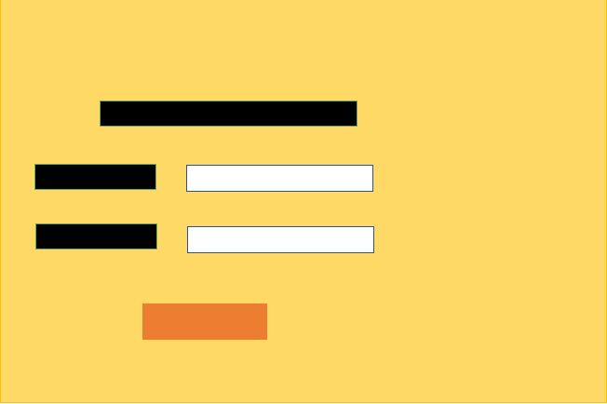

**Description:**

I have use here three labels, two text box, one button and one specific image for background.

**For image (Deep Yellow):** The deep yellow color use here for the form background. This is a background picture.

**Labels (Black):** On the top and at the left sides, there are three black color boxes. They are labels. They show some specie index.

**Text-Box (White):** In the middle there are two white boxes. They are text box. They use for input user name and email.

**Button (Deep Red):** In the bottom a deep red box. It is button. It uses for calling the next form.

1. **Main form**

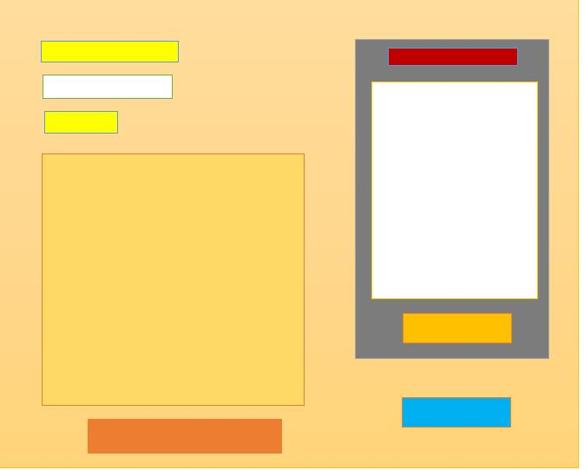

**Description:**

**For image (Brown):** The brown color use here for the form background. This is a background picture.

**Labels (Yellow and Golden):** On the top of the left side there are two black color boxes and its bottom a golden large box. They are labels. They show some specie index and story.

**Group-Box (Gray):** Right side a gray box is shown. It is group-box**.** It is use for append two label and a button for working both same type.

**Brown (Form):** This is main form. Here I use a picture and its color as like this.

**Label (Red):** On the top of the right side a red color box is shown. It is label. They show some specie index.

**List-Box (White):** On the right side a white box shown. This is List-box. I make it background white for easily show and select related question.

**Button (Deep Red):** In the bottom a deep red box. It is button. It uses for showing related option.

**Button (Deep Yellow):** On the bottom of the right side a deep yellow box. It is button. It uses for showing related story.

**Button (Deep Blue):** On the bottom of the right side a deep blue box. It is button. It uses for save story.

**Overview of Method and Experience:**

This application was checked by a user and used the application easily and overall frameworks was fine. All the functions work perfectly. This application works user friendly. The system has all the essential requirements for “Story Exploration”. But if it adding some extra system, it will make this application more expensive. At last I can say that it is a better application but try to add it some extra features it will more better.

**Recommendation for Changes:**

I have finished the project with all the following requirements but still I want to improved my project by adding some extra functions. On this application I can’t make blank check. So, I can improve my application by adding this system. I can’t provide save button function. In future I will solve this problem. I can’t provide here any exit button so user can know how he left the application. In future update will make an exit button function. I am also update this application graphical interface.

**Conclusion:** Every people have different choice. I have try my best to fulfil all the requirements of the program. I have used cartoon picture, beautiful color and simple design for making it user friendly. I already checked this application both black and white. It makes the application more better. I never say that is a high-level application but user will feel pleasure and easy using the application.